Fire Tablet filming instructions for pupils

1. Tap Stop Motion Studio in apps.
2. Tap New Movie.
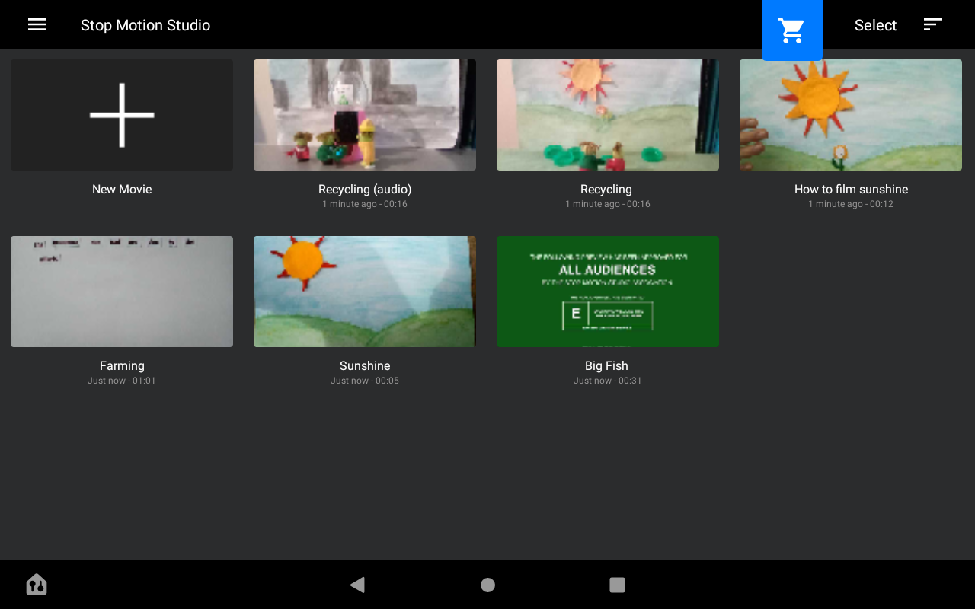

3. Tap red button to take a shot, move an object, take another shot, move an object, take another shot. . .
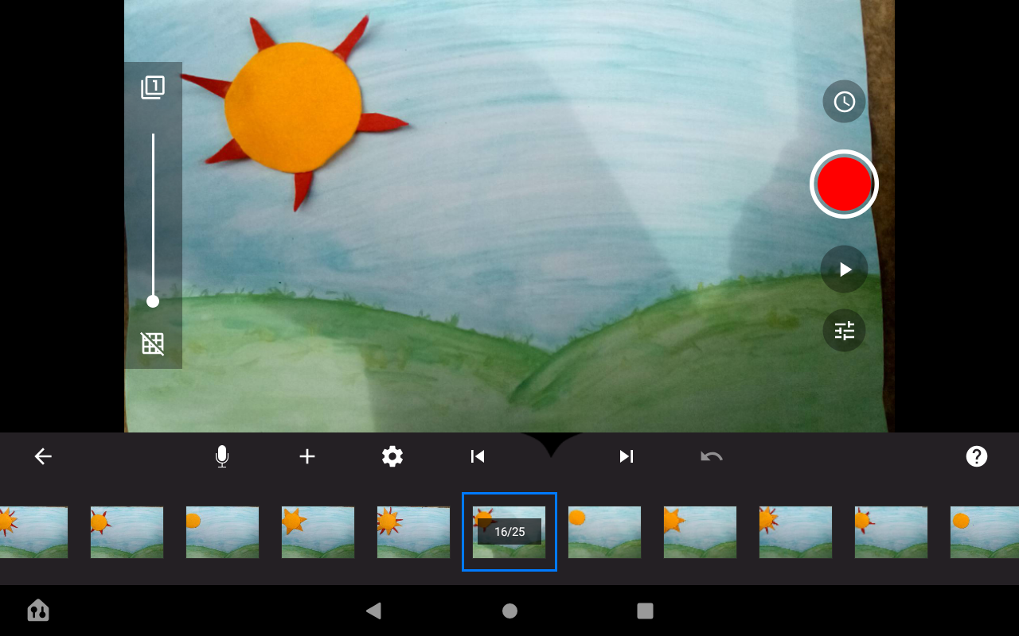
4. Tap play to view your movie.
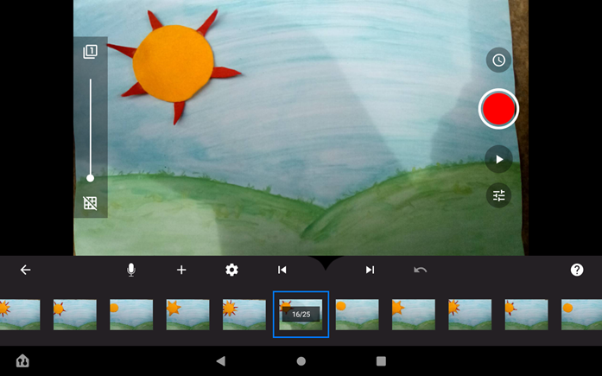

*To delete a slide, tap the slide and tap delete.
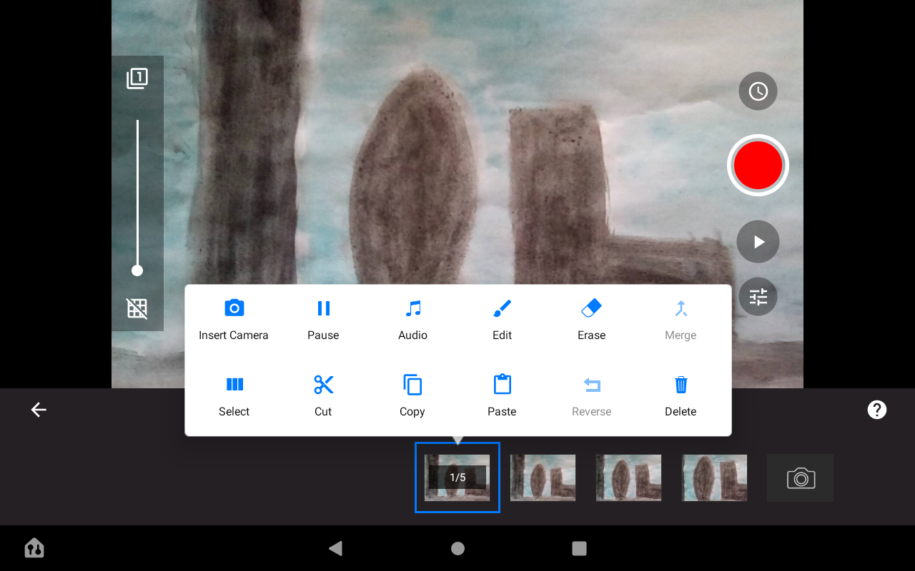

Fire Tablet audio instructions for pupils

1. Find the audio button in the shape of a microphone.

2. Tap - it says ready to record and you press the orange record button.
3. It starts a three-two-one timer.
4. When it gets to zero you speak.
5. When you are ready to stop you press the orange stop button.
6. You press play to view your film!

Fire Tablet saving instructions for pupils

1. Press back to movie screen.
2. Tap the title of your movie.
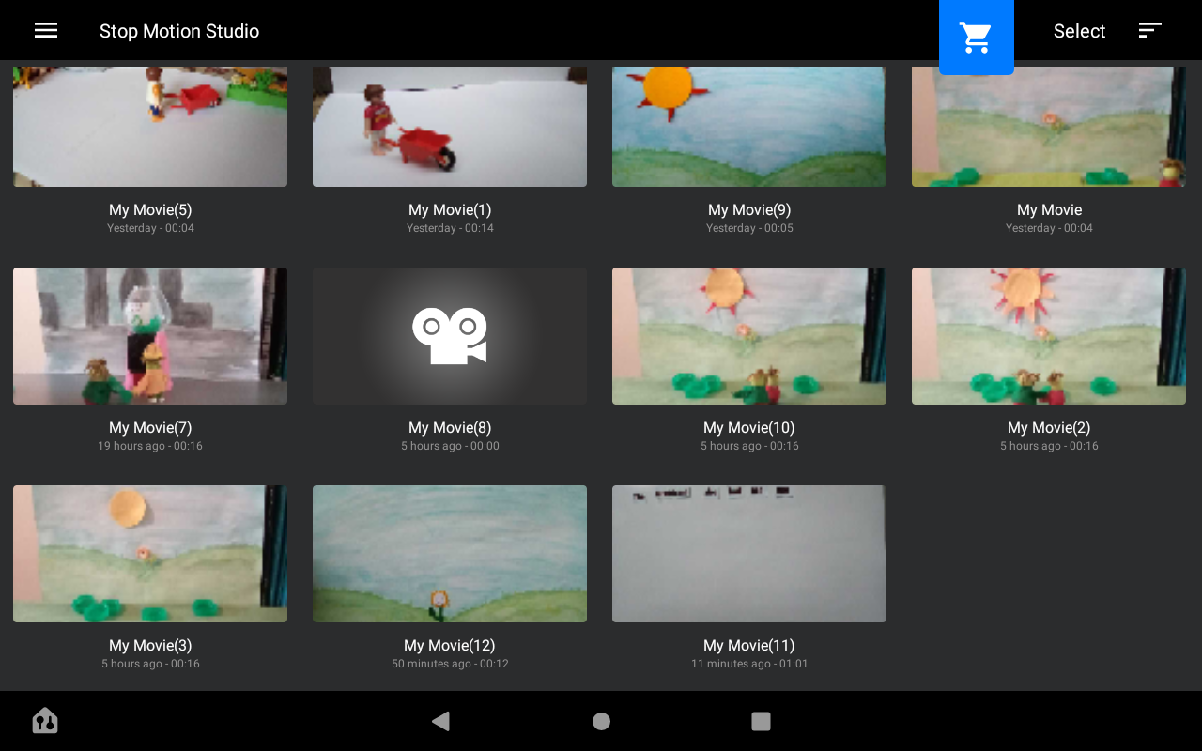
3. Write the new title and tap okay.
4. Press down on the picture of your movie so that it is selected.
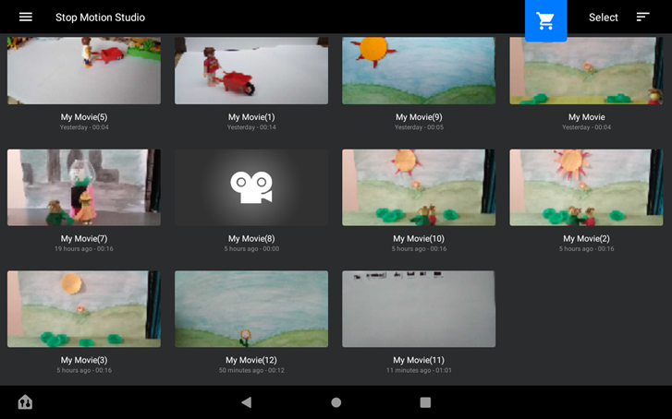
5. Tap the share icon at the top left of the screen.

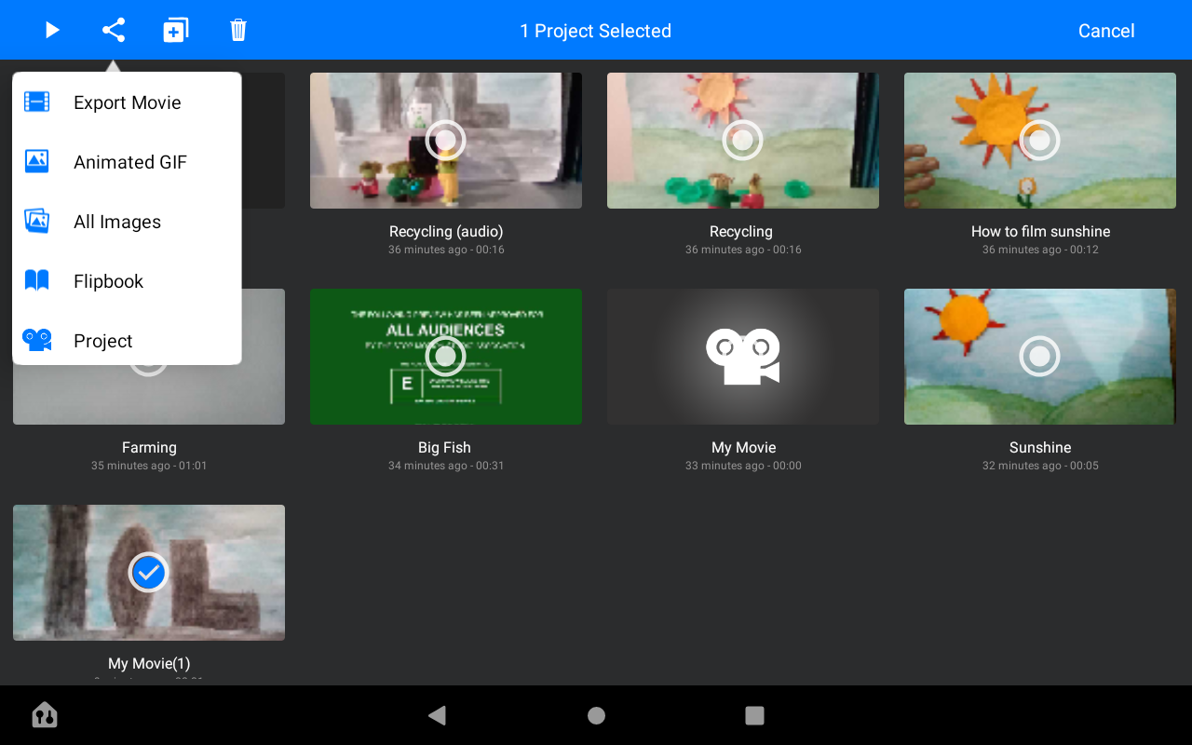

6. Then tap export movie.
7. Then tap save as.
8. Tap save.

Fire Tablet instructions for teachers
(including saving a film to laptop instructions for teachers)*
Fire Tablet filming instructions
1. Tap Stop Motion Studio in apps.
2. Tap New Movie.
3. Tap red button to take a shot, move an object, take another shot, move an object, take another shot. . .
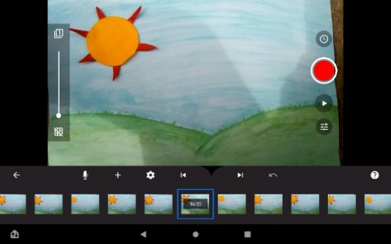
4. Tap play to view your movie.
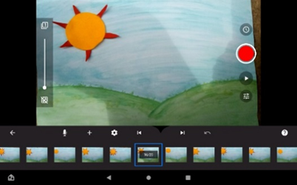
*To delete a slide, tap the slide and tap delete.
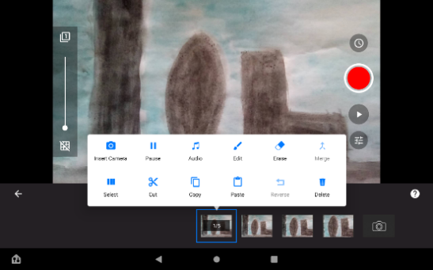

Fire Tablet adding audio instructions
1. Find the audio button in the shape of a microphone.
2. Tap - it says ready to record and you press the orange record button.
3. It starts a three-two-one timer.
4. When it gets to zero you speak.
5. When you are ready to stop you press the orange stop button.
6. You press play to view your film!

Fire Tablet saving instructions
1. Press back to movie screen.
2. Tap the title of your movie.
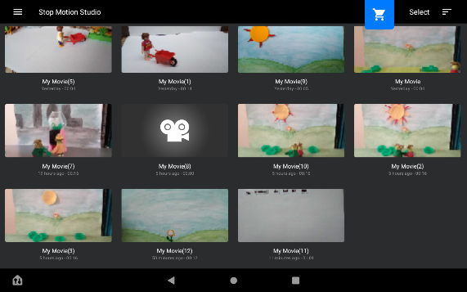
3. Write the new title and tap okay.
4. Press down on the picture of your movie so that it is selected.
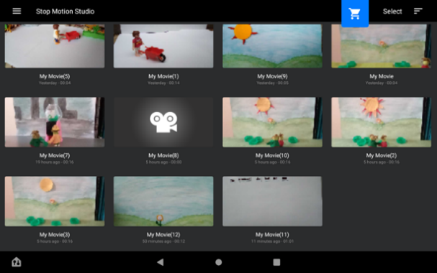
5. Tap the share icon at the top left of the screen.

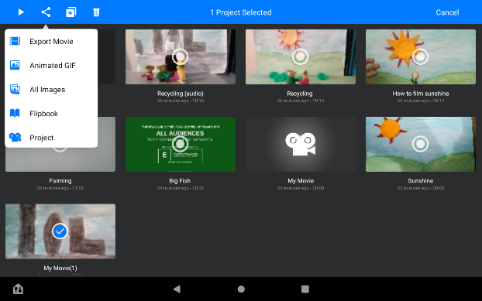
6. Then tap export movie.
7. Then tap save as.
8. Tap save.
*To delete a movie, tap the bin icon and tap the movie.

*Fire Tablet saving a film to laptop instructions for teachers
1. Plug USB into FireTablet and laptop.
2. Pull down menu on FireTablet and at very bottom of list find Android System (says USB charging) – tap.
3. Select File Transfer.
4. On laptop go to File Explorer – this PC – Fire.
5. Click on Internal Shared Storage.
6. Click into download folder and you will see movies to copy.
7. Copy and paste into selected folder.

